**GASTROINTESTINAL SYSTEM**

**Hepatobiliary System**

**Liver**

* The liver is the largest internal organ, and the body’s second largest, after the skin. It has four lobes and is surrounded by a capsule of fibrous connective tissue called Glisson’s capsule.
* The bulk of the liver consists of hepatocytes, which are epithelial cells with a unique configuration.
* The liver is essentially an exocrine gland, secreting bile into the intestine. But the liver is also an endocrine gland and a blood filter.
* The liver is a metabolic factory, synthesizing and breaking down a variety of substances.
* Its functions includes all of the following:
  + - Formation and secretion of **bile**.
    - Storage of **glycogen**, buffer for blood glucose.
    - Synthesis of **urea**.
    - Metabolism of **cholesterol** and **fat**.
    - Synthesis and endocrine secretion of many **plasma proteins**, including **clotting factors**.
    - **Detoxification** of many drugs and other poisons.
    - **Cleansing of bacteria** from blood.
    - Processing of several **steroid hormones** and **vitamin D**.
    - **Volume reservoir** for blood.
    - Catabolism of **hemoglobin** from worn-out red blood cells.

**Basic Histology and Organization**

* The liver is organized into **lobules** which take the shape of **polygonal prisms**.
* Each lobules is typically hexagonal in cross-section and is centered on a branch of the **hepatic vein** (called, logically enough, the **central vein**).
* Within each lobules, **hepatocytes** are arranged into **hepatic cords** separated by **adjacent sinusoids**.
* Cells forms the **plates** (**one cell thick**)that branch and anastomose with one another to form a network. Spaces within the network are occupied by **sinusoids**.

**CIRRHOSIS:**

It represents the **irreversible end-stage** of several diffuse diseases causing **hepatocellular injury** and is characterised by the following 4 features:

* 1. It involves the entire liver.
  2. The normal lobular architecture of hepatic parenchyma is disorganised.
  3. There is formation of nodules separated from one another by irregular bands of fibrosis.
  4. It occurs following hepatocellular necrosis of varying etiology so that there are alternate areas of necrosis and regenerative nodules.

**PATHOGENESIS**

Initiated by hepatocellular necrosis. Continued destruction of hepatocytes causes collapse of normal lobular hepatic parenchyma followed by ***fibrosis***around necrotic liver cellsand proliferated ductules and there is formation of compensatory ***regenerative nodules.***

**Fibrogenesis:**

* The mechanism of fibrosis is by increased synthesis of all types of **collagen** and increase in the number of **collagen-producing cells**.
* In cirrhosis, there is proliferation of **fat-storing** ‘**ITO’ cells** and transformed into **myofibroblasts** and **fibrocytes**.
* Two **glycoproteins**, fibronectin and laminin, are deposited in excessive amounts in area of liver cell damage.
* **Stimulants** for fibrosis are lymphokines and monokines.

**Regenerative Nodule:**

* Proliferation of hepatocytes to form regenerative nodules is unclear.
* Possibly, **growth factors**, **hormonal imbalance**, play a role in regeneration.

**TABLE: Classification of Cirrhosis.**

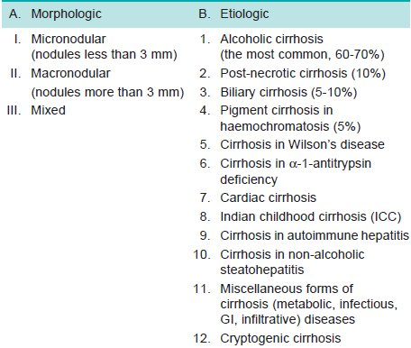

**CLASSIFICATION**

Cirrhosis can be classified on the basis of morphology and etiology

1. **Morphologic Classification.**

There are 3 morphologic types of cirrhosis—

* 1. Micronodular,
  2. Macronodular
  3. Mixed

Each of these forms may have an active and inactive form.

1. An *active form* is characterised by continuing hepatocellular necrosis and inflammatory reaction, a process that closely resembles chronic hepatitis.
2. An *inactive form,* on the other hand, has no evidence of continuing hepatocellular necrosis and has sharply-defined nodules of surviving hepatic parenchyma without any significant inflammation.
3. **Micronodular cirrhosis.**

* Nodules are usually regular and small, ***less than 3 mm*** indiameter. There is diffuse involvement of all the hepatic lobules forming nodules by **thick fibrous septa**.
* The micronodular cirrhosis includes etiologic type of alcoholic cirrhosis (or nutritional cirrhosis) and represents **impaired capacity for re-growth** as seen in alcoholism, malnutrition, severe anaemia and old age.

**2. Macronodular cirrhosis.**

* Nodules are of variable size and are generally ***larger than 3 mm*** in diameter*.*
* The pattern of involvement is more irregular than in micronodular cirrhosis, **sparing** some portal tracts and central veins, and more marked evidence of **regeneration**.

**3. Mixed cirrhosis.**

* In mixed type, some parts of the liver show **micronodular** appearance while other parts show **macronodular** pattern. All the portal tracts and central veins are not involved by fibrosis but instead some of them are spared.

**B. Etiologic Classification.**

* 1. Alcoholic cirrhosis
  2. Post-necrotic cirrhosis
  3. Biliary cirrhosis
  4. Pigment cirrhosis in haemochromatosis (5%)
  5. Cirrhosis in Wilson’s disease
  6. Cirrhosis in α-1-antitrypsin deficiency
  7. Cardiac cirrhosis
  8. Indian childhood cirrhosis (ICC)
  9. Cirrhosis in autoimmune hepatitis
  10. Cirrhosis in non-alcoholic steatohepatitis
  11. Miscellaneous forms of cirrhosis (metabolic, infectious, GI,infiltrative) diseases
  12. Cryptogenic cirrhosis

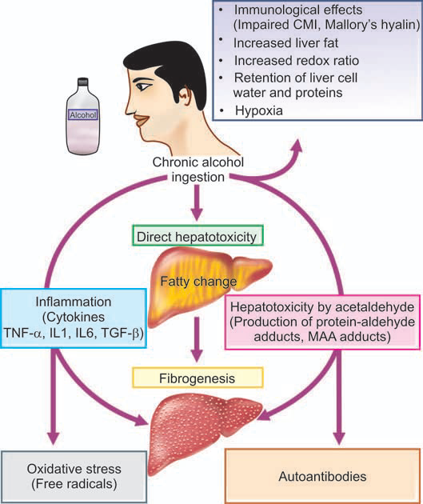

**Fig: Pathogenesis of alcoholic liver disease.**

**CHOLECYSTITIS**

* Cholecystitis or inflammation of the gallbladder may be acute, chronic, or acute superimposed on chronic.
* Chronic cholecystitis is more common, acute cholecystitis is a surgical emergency.

**Acute Cholecystitis**

The condition usually begins with obstruction, followed by infection later.

**ETIOPATHOGENESIS**

**Acute calculous cholecystitis.**

* 90%, acute cholecystitis is caused by obstruction in the neck of the gallbladder or in the cystic duct by a gallstone.
* Obstruction results in enlargement of the gallbladder followed by acute inflammation which is initially due to chemical irritation.
* Later, secondary bacterial infection, chiefly by *E. coli* and *Streptococcus faecalis.*

**Acute acalculous cholecystitis**

* 10%, do not contain gallstones but may be due to previous non-biliary surgery, multiple injuries, burns, recent childbirth, severe sepsis, dehydration, torsion of the gallbladder and diabetes mellitus.
* Rare causes include primary bacterial infection like salmonellosis and cholera and parasitic infestations.

**MORPHOLOGIC FEATURES.**

* **Grossly,** serosal surface is coated with fibrinous exudate with congestion and haemorrhages.
* The mucosa is bright red.
* The lumen is filled with pus mixed with green bile.
* In calculous cholecystitis, a stone is generally impacted in the neck or in the cystic duct.
* When obstruction of the cystic duct is complete, the lumen is filled with purulent exudate and the condition is known as *empyema of the gallbladder.*

**Microscopically,**

* Thewall of the gallbladder shows marked inflammatory oedema, congestion and neutrophilic exudate.
* There may be abscesses in the wall and gangrenous necrosis with rupture into the peritoneal cavity *(gangrenous cholecystitis).*

**Chronic Cholecystitis**

Commonest type of clinical gallbladder disease. There is almost constant association of chronic cholecystitis with cholelithiasis.

**ETIOPATHOGENESIS**

* Supersaturation of the bile with cholesterol predisposes to both gallstone formation and inflammation.
* In some patients, repeated attacks of mild acute cholecystitis result in chronic cholecystitis.

**MORPHOLOGIC FEATURES**

***Grossly,***

* May be normal or enlarged.
* Wall of the gallbladder is thickened which on cut section is grey-white due to dense fibrosis or may be even calcified.
* The mucosal folds may be intact, thickened, or flattened and atrophied.
* The lumen commonly contains multiple mixed stones or a combined stone.

***Histologically,***

1. Thickened and congested mucosa but occasionally mucosa may be totally destroyed.
2. Penetration of the mucosa deep into the wall of the gallbladder up to muscularis layer to form *Rokitansky- Aschoff’ sinuses.*
3. Variable degree of chronic inflammatory reaction, consisting of lymphocytes, plasma cells and macrophages, present in the lamina propria and subserosal layer.
4. Variable degree of fibrosis in the subserosal and subepithelial layers.

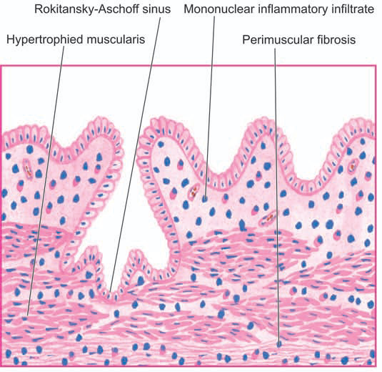

**Fig: Chronic cholecystitis.** There is penetration of epithelium-lined spaces into the gallbladder wall (Rokitansky-Aschoff sinus) in an area. There is subepithelial and subserosal fibrosis and hypertrophy of muscularis. Mononuclear inflammatory cell infiltrate is present in subepithelial and perimuscular layers.

**CHOLELITHIASIS (GALLSTONES)**

* Gallstones are formed from constituents of the bile (viz. cholesterol, bile pigments and calcium salts) along with other organic components.
* Accordingly, the gallstones commonly contain cholesterol, bile pigment and calcium salts in varying proportions.
* They are usually formed in the gallbladder, but may develop within extrahepatic and intrahepatic bile duct.

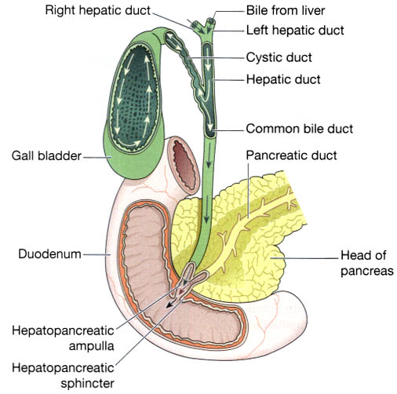

**RISK FACTORS**

1. **Geography:** American Indians have the highest known prevalence. Black Africans and populations in the Eastern world are relatively low risk.
2. **Genetic factors:** Recently, mutation in *CYP7A1* gene, results in deficiency of enzyme, cholesterol 7-hydroxylase, which has a role in bile acid synthesis. This mutation is associated with hypercholesterolaemia and gallstones.
3. **Age:** Incidence increases above the age of 40 and presentation is usually in the 50s and 60s.
4. **Sex:** Twice more frequent in women than in men.
5. **Drugs:** Women on oestrogen therapy or on birth control pills have higher incidence of gallstones due to production of more lithogenic bile
6. **Obesity:** Obesity is associated with increased cholesterol synthesis and its excretion resulting in higher incidence of gallstones in obese patients.
7. **Diet:** Deficiency of dietary fibre content is linked to higher prevalence of gallstones.
8. **Gastrointestinal diseases:** Interruption in enterohepatic circulation followed by gallstone formation.

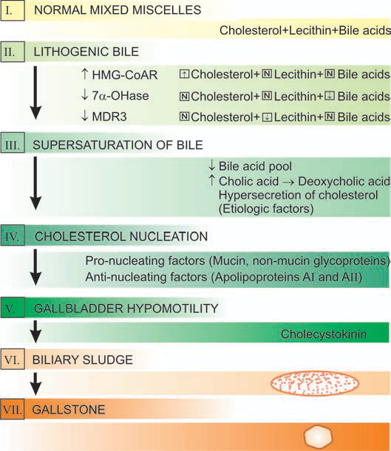

**Fig: Schematic pathogenesis of gallstone formation.**

(HMGCoAR = hydroxy methyl glutaryl-coenzyme A reductase; 7α-OHase = cholesterol 7 α-OHase hydroxylase; MDR3 = multidrug resistance-associated protein 3).

**TABLE : Features of Gallstones.**

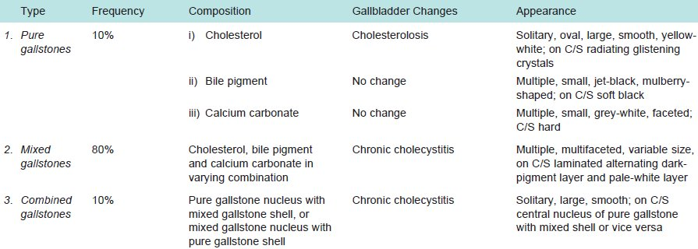

**PANCREATITIS**

* Pancreatitis is inflammation of the pancreas with acinic cell injury.
* It is classified into acute and chronic forms

**Acute Pancreatitis**

* Acute inflammation of the pancreas.
* The severe form of the disease associated with macroscopic **haemorrhages** and **fat necrosis** in and around the pancreas is termed ***acute haemorrhagic pancreatitis or acute pancreatic necrosis****.*
* Incidence 40 and 70 years; common in females than in males.
* Sudden onset; occurring after a bout of alcohol or a heavy meal. The patient presents with abdominal pain, vomiting and collapse.
* Characteristically, there is elevation of *serum amylase* level within the first 24 hours and elevated *serum lipase* level after 3 to 4 days, the latter being more specific for pancreatic disease.
* Glucosuria occurs in 10% of cases.

**ETIOLOGY**

Most common (80%)

* + **Alcoholism**
  + **Cholelithiasis,**

**Other includes:**

* + Trauma, ischaemia, shock, extension of inflammation from the adjacent tissues,
  + blood-borne bacterial infection, viral infections,
  + certain drugs (e.g. thiazides, sulfonamides, oral contraceptives),
  + hyperlipoproteinaemia and hypercalcaemia from hyperparathyroidism.
  + Some may idiopathic

**PATHOGENESIS**

The destructive changes in the pancreas are attributed to the liberation and activation of pancreatic enzymes.

1. ***Proteases***such as trypsin and chymotrypsin play the most important role in causing proteolysis. This results in inflammation, thrombosis, tissue damage and haemorrhages found in acute haemorrhagic pancreatitis.
2. ***Lipases and phospholipases*** degrade lipids and membrane phospholipids.
3. ***Elastases***cause destruction of the elastic tissue of the blood vessels.

The activation and release of these enzymes is brought about by one of the following mechanisms:

* ***Acinic cell damage*** caused by the etiologic factors such as alcohol, viruses, drugs, ischaemia and trauma result in release of intracellular enzymes.
* ***Duct obstruction*** caused by cholelithiasis, chronic alcoholism and other obstructing lesions is followed by leakage of pancreatic enzymes from the ductules into the interstitial tissue.

**Chronic Pancreatitis**

* Chronic pancreatitis or *chronic relapsing pancreatitis* is the progressive destruction of the pancreas due to repeated mild and subclinical attacks of acute pancreatitis.
* Recurrent attacks of severe abdominal pain at intervals of months to years.
* Weight loss, jaundice, diabetes mellitus and steatorrhoea.
* Abdominal radiographs show calcification in the region of pancreas and presence of pancreatic calculi in the ducts.

**ETIOLOGY**

* Same factors as for acute pancreatitis.
* Chronic alcoholism with protein-rich diet, biliary tract disease.
* Familial hereditary pancreatitis
* Hypercalcaemia, hyperlipidaemia

**PATHOGENESIS**

* Chronic pancreatitis due to chronic alcoholism accompanied by a high-protein diet results in increase in protein concentration in the pancreatic juice which obstructs the ducts and causes damage.
* Non-alcoholic cases, result from protein-calorie malnutrition.
* Genetic factors play a role in some cases of chronic pancreatitis.

**HEPATITIS**

* **Inflammation** of the liver which **damages** liver cells and may ultimately kill them.
* Acute injury of the liver is usually followed by complete recovery, but prolonged inflammation after injury may result in **fibrosis** and **cirrhosis**.

**Etiology:**

Excluding trauma, hepatitis has several **causes**:

* **Viral infections** by any of hepatitis A, B, C, D, or E viruses and also Cytomegalovirus (CMV), Epstein Barr Virus, and Herpes Simplex.
* **Autoimmune disorders** such as autoimmune chronic hepatitis, toxins, alcohol and certain drugs – isoniazid, rifampicin, chlorpromazine.
* **Wilson’s Disease** (an increased accumulation of copper in the liver)
* **Alcoholic hepatitis**
* **Fatty liver (diabetes, obesity, hyperlipidemia**)
* **Ischemic hepatitis** (shock liver)
* Therefore, **Viral hepatitis** is the **most common** cause of hepatitis worldwide.
* Other **common causes** of non-viral hepatitis include toxic and drug-induced, alcoholic, autoimmune, fatty liver, and metabolic disorders.

**Types of hepatitis**

**Hepatitis A**

* This is caused by eating **infected food or water**.
* The food or water is infected with a virus called **HAV** (hepatitis A virus).
* Anal-oral contact during sex can also be a cause.
* Nearly everyone who develops Hepatitis A makes a full recovery - it does not lead to chronic disease.

**Hepatitis B**

* This is an **STD** (sexually transmitted disease).
* It is caused by the virus **HBV** (hepatitis B virus) and is spread by contact with **infected blood, semen, and some other body fluids**. One can get hepatitis B by:
  + **Unprotected sexual intercourse** with an infected person, Using a syringe that was previously used by an infected person.
  + Having your **skin perforated** with unsterilized needles, as might be the case when getting a tattoo, or being accidentally pricked. People who work in **health care risk** becoming infected by accident in this way. **Sharing** personal items, such as a toothbrush or razor, with an infected person.
  + A **baby** can become infected through his **mother's milk** if she is infected.
  + Being **bitten** by someone who is infected.
* The liver of a person infected with hepatitis B **swells**. The patient can suffer serious **liver damage** due to infection, resulting in **cancer**. For some patients the hepatitis becomes chronic (very long-term or lifelong).
* Donated blood is **always tested** for hepatitis B.

**Hepatitis C**

* Hepatitis C is usually spread through **direct contact** with the blood of a person who has the disease.
* It is caused by the virus **HCV** (hepatitis C Virus).
* The liver can **swell** and become **damaged**.
* In hepatitis C, unlike hepatitis B, liver **cancer risk** is only increased in people with **cirrhosis** and only 20% of hep C patients get cirrhosis.
* Feces is never a route of transmission in hepatitis C.
* Donated blood is also **tested** for hepatitis C.

**Hepatitis D**

* Only a person who is **already** infected with **hepatitis B** can become infected with **hepatitis D**.
* It is caused by the virus **HDV** (Hepatitis D Virus).
* Infection is through contact with **infected blood, unprotected sex, and perforation of the skin with infected needles**.
* The liver of a person with Hepatitis D **swells**.

**Hepatitis E**

* A person can become infected by **drinking water** that contains **HEV** (hepatitis E virus).
* The liver **swells** but there is no long-term consequence.
* Infection is also possible through anal-oral sex.

**TABLE: Features of Various Types of Hepatitis Viruses.**

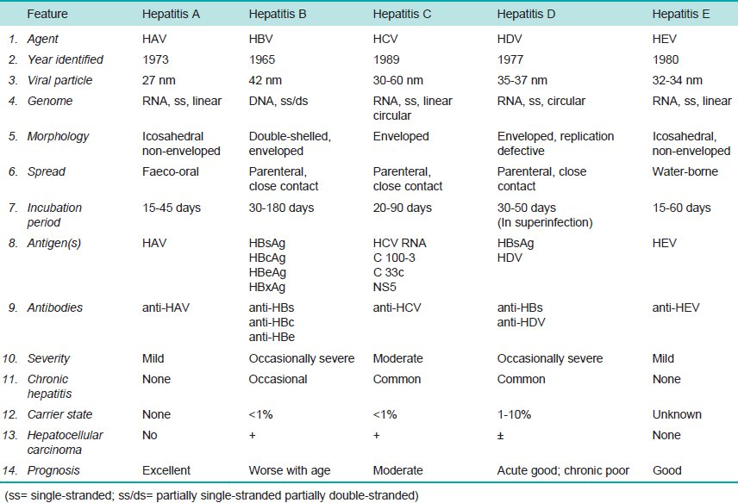

**THE ORAL CAVITY**

* The oral cavity is the point of entry for digestive and respiratory tracts.
* The mucous membrane of the mouth consists of **squamous epithelium** covering **vascularised connective tissue**.
* The epithelium is **keratinised** over the hard palate, lips and gingiva, while elsewhere it is **non-keratinised**.
* **Mucous glands** (minor **salivary glands**) are scattered throughout the oral mucosa.
* **Sebaceous glands** are present in the region of the lips and the buccal mucosa only. **Lymphoid tissue** is present in the form of tonsils and adenoids.
* The oral cavity is the site of numerous **congenital** and **acquired diseases**.

**STOMATITIS**

**Inflammation of the mucous membrane** of the mouth is called stomatitis. It can occur in the course of several different diseases.

1. **Aphthous ulcers (Canker sores):** 
   * Commonest form of oral ulceration. Etiology is unknown but may be precipitated by **emotional factors**, **stress**, **allergy**, **hormonal imbalance**, **nutritional deficiencies**, **gastrointestinal disturbances**, **trauma** etc.
   * The condition is characterised by **painful oral ulcers**, 1 cm or more in size.
   * Lesions can be **solitary or multiple**; typically, they are shallow, **hyperemic** ulcerations covered by a thin **exudate** and rimmed by a narrow zone of **erythema**
2. **Herpetic stomatitis** 
   * An acute disease occurring in infants and young children.
   * Most common manifestation of primary infection with **herpes simplex virus**.
   * The lesions are in the form of **vesicles** around the lips. Similar lesions may appear on the genital skin.
   * Recurrent attacks occur due to stress, emotional upsets and upper respiratory infections.
3. **Necrotising stomatitis (Noma or Cancrum oris)** 
   * Occursmore commonly in **poorly-nourished** children like in **kwashiorkor**; infectious diseases such as **measles, immunodeficiencies and emotional stress.**
   * The lesions are characterised by **necrosis** of the marginal gingiva and may extend on to oral mucosa, causing **cellulitis** of the tissue of the cheek.
   * The condition may progress to **gangrene** of the cheek.
4. **Mycotic infections**

* Commonly involving the oral mucosa are **actinomycosis** and **candidiasis**.
* ***Cervicofacial actinomycosis*** is the commonest form of the disease developing at the angle of the mandible.
* ***Candidiasis*** *(moniliasis or* ***thrush****)* is caused by ***Candida albicans*** which is a commensal in the mouth. It appears as an **opportunistic infection** in immunocompromised host. There are **erythematous** lesions.
  + The three major clinical forms of **oral** **candidiasis** are:
    - 1. **pseudomembranous,**
      2. **erythematous, and**
      3. **hyperplastic.**
  + The pseudomembranous form is most common and is known as ***thrush****.* This condition is characterized by a superficial, **curd-like**, **gray to white** inflammatory membrane composed of matted organisms enmeshed in a **fibrinosuppurative** **exudate** that can be readily scraped off to reveal an underlying erythematous base.

**GLOSSITIS**

* **Acute glossitis** characterised by swollen papillae occurs in eruptions of measles and scarlet fever.
* In **chronic glossitis,** the tongue is raw and red without swollen papillae and is seen in malnutrition such as in **pellagra**, **ariboflavinosis** and **niacin** deficiency.
* In iron deficiency anaemia, pernicious anaemia and sprue, there is ***chronic atrophic glossitis****.*

**SYPHILITIC LESIONS**

* Oral lesions may occur in primary, secondary, tertiary and congenital syphilis.
* **P*rimary syphilis*** *occurs most* commonly on the lips.
* **S*econdary syphilis*** shows maculopapular eruptions and mucous patches in the mouth.
* In the ***tertiary syphilis***, **gummas or diffuse fibrosis** may be seen on the hard palate and tongue.
* Oral lesions of the ***congenital syphilis*** are fissures at the angles of mouth

**HIV INFECTION**

HIV infection of low grade as well as full-blown acquired immunodeficiency syndrome **(AIDS)** are associated with oral manifestations such as **opportunistic infections, malignancy, leukoplakia and others**.

**TABLE: Oral Manifestations of AIDS.**

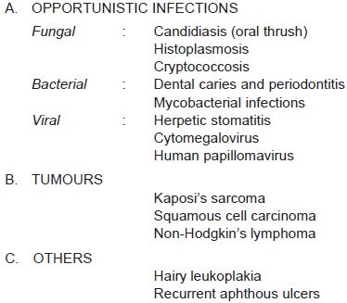

**Tumor-Like Lesions**

***Fibromas***

* Are submucosal **nodular fibrous tissue masses** that are formed when chronic irritation results in reactive **connective tissue hyperplasia**.
* They occur most often on the **buccal mucosa** and are thought to be reactions to **chronic irritation**.
* Treatment is complete surgical excision and removal of the source of irritation.

***Pyogenic granulomas***

* are **pedunculated masses** usually found on the gingiva of children, young adults, and pregnant women.
* These lesions are richly **vascular** and typically are **ulcerated**, which gives them a **red to purple color**.
* May grow rapid and raise into **malignant** neoplasm.
* However, histologic examination demonstrates a **dense proliferation of immature vessels.**
* Pyogenic granulomas can **regress**, **mature** into **dense fibrous masses**, or develop into a peripheral **ossifying fibroma**.
* Complete surgical excision is definitive treatment.

**PEPTIC ULCERS**

* Peptic ulcers are the areas of **degeneration and necrosis** of gastrointestinal mucosa exposed to **acid-peptic secretions**.
* Can occur at any level of the alimentary tract that is exposed to **hydrochloric acid and pepsin**,
* They occur most commonly (98-99%) in either the duodenum or the stomach in the ratio of 4:1.
* May be acute or chronic.

**Acute Peptic (Stress) Ulcers**

Acute peptic ulcers or stress ulcers are **multiple**, **small mucosal erosions**, seen most commonly in the stomach but occasionally involving the duodenum.

**ETIOLOGY**

These ulcers occur following severe stress

* 1. ***Psychological stress***
  2. ***Physiological stress*** as in the following:
     + - Shock
       - Severe trauma
       - Septicaemia
       - Extensive burns (Curling’s ulcers).
       - Intracranial lesions (hyperacidity).
       - Drug intake (e.g. aspirin, steroids, butazolidine, indomethacin).
       - Local irritants (e.g. alcohol, smoking, coffee etc).

**PATHOGENESIS.**

* It is **not clear** how the mucosal erosions occur
* Actual **hypersecretion of gastric acid** is demonstrable in only Cushing’s ulcers occurring from intracranial conditions such as due to brain trauma, intracranial surgery and brain tumours.
* Possible hypotheses for genesis of stress ulcers are as under:
  + 1. **Ischaemic hypoxic** injury to the mucosal cells.
    2. **Depletion of the gastric mucus ‘barrier’** rendering the mucosa susceptible to attack by acid-peptic secretions.

**MORPHOLOGIC FEATURES.**

***Grossly,*** *acute stress* ulcers are **multiple** (more than three ulcers in 75% of cases).

* They may be **oval** or **circular** in shape, usually **less than 1 cm** in diameter.

***Microscopically,***

* **Do not invade the muscular layer**. The margins and base may show some **inflammatory reaction** depending upon the duration of the ulcers.
* These ulcers commonly **heal** by complete **re-epithelialisation** without leaving any scars.
* Complications such as **haemorrhage** and **perforation** may occur.

**Chronic Peptic Ulcers (Gastric and Duodenal Ulcers)**

more frequent in middle-aged adults. The peak incidence for duodenal ulcer is 5th decade, while for gastric ulcer it is a decade later (6th decade).

Duodenal as well as gastric ulcers are more common in males than in females.

**ETIOLOGY**

The immediate cause of peptic ulcer disease is **disturbance** in normal protective **mucosal ‘barrier**’ by acid-pepsin, resulting in digestion of the mucosa.

1. **Helicobacter pylori gastritis.**

About 15-20% cases infected with *H. pylori* in the antrum develop duodenal ulcer in their life time. *H. pylori* can *be* identified in mucosal samples by histologic examination, culture and serology.

1. **NSAIDs-induced mucosal injury.**

Non-steroidal anti-inflammatory drugs (aspirin, paracetamol, ibuprofen) are most commonly used medications in the developed countries and are responsible for **direct toxicity**, **endothelial damage** and **epithelial injury** to both gastric as well as duodenal mucosa.

1. **Acid-pepsin secretions.**
2. **Gastritis**
3. **Other local irritants** like heavily spiced foods, alcohol, cigarette smoking.
4. **Psychological factors.**
5. **Genetic factors.**
6. **Hormonal factors.**
7. **Miscellaneous.** such as alcoholic cirrhosis, chronic renal failure, hyperparathyroidism, chronic obstructive pulmonary disease, and chronic pancreatitis.

**PATHOGENESIS.**

Two most important factors in peptic ulcer are as under:

* + Exposure of mucosa to gastric acid and pepsin **secretion**.
  + Strong etiologic association with ***H. pylori*** infection*.*
* There is generally ***hypersecretion of gastric acid*** into the fasting stomach at night which takes place under the influence of vagal stimulation.
* Patients of duodenal ulcer have ***rapid emptying*** of the stomach so that the food which normally buffers and neutralises the gastric acid, passes down into the small intestine, leaving the duodenal mucosa exposed to the aggressive action of gastric acid.

1. ***Helicobacter gastritis*** caused by ***H. pylori*** 
   1. Gastric ***mucosal defense is broken*** by bacterial elaboration of urease, protease, catalase and phospholipase.
   2. ***Host factors****: H. pylori-*infected mucosal epithelium releases proinflammatory cytokines such as IL-1, IL-6, IL-8 and tumour necrosis factor-α, all of which leads to inflammatory reaction.
   3. ***Bacterial factors****:* Epithelial injury is also induced by cytotoxin-associated gene protein (CagA), while vacuolating cytotoxin (VacA) induces elaboration of cytokines.

**INTESTINAL TUBERCULOSIS**

Intestinal tuberculosis can occur in 3 forms—**primary**, **secondary** and **hyperplastic** **caecal** **tuberculosis**.

1. **PRIMARY INTESTINAL TUBERCULOSIS.**

* In the prepasteurisation era, it used to occur by ingestion of unpasteurised cow’s milk infected with *Mycobacterium bovis.*
* But now-a-days due to control of tuberculosis in cattle and pasteurisation of milk, virtually all cases of intestinal tuberculosis are caused by ***M. tuberculosis****.*
* The predominant changes are in the mesenteric lymph nodes without any significant intestinal lesion.

***Grossly,*** the affected lymph nodes are **enlarged** and **matted**. Eventually, there is healing by **fibrosis** and **calcification**

***Microscopically,*** there is **primary complex** or **Ghon’s focus** in the intestinal mucosa.

* Mesenteric lymph nodes are affected which show typical tuberculous **granulomatous inflammatory reaction** with **caseation** (cheese-like mass) **necrosis**.
* Tuberculous peritonitis may occur due to spread of the infection.

**2. SECONDARY INTESTINAL TUBERCULOSIS.**

**Self-swallowing** of sputum in patients with active pulmonary tuberculosis may cause secondary intestinal tuberculosis, most commonly in the terminal ileum and rarely in the colon.

**Groosly**, the lesions begin in the Peyer’s patches or the lymphoid follicles with formation of **small ulcers** that spread through the lymphatics to form large ulcers.

* Serosa may be studded with visible tubercles.
* In advanced cases, transverse **fibrous** **strictures** and **intestinal** **obstruction** are seen.

***Histologically,*** tuberculous lesions in the intestine shows the presence of **tubercles**.

* Mucosa and submucosa show **ulceration** and the muscularis may be replaced by variable degree of **fibrosis**.
* Tuberculous peritonitis may be observed.
* **HYPERPLASTIC CAECAL TUBERCULOSIS.**

This is a variant of occurring secondary to pulmonary tuberculosis.

***Grossly***, the caecum or ascending colon are **thick-walled** with **mucosal ulceration**. Clinically, the lesion is palpable and may be mistaken for carcinoma.

***Microscopically,*** the presence of **caseating** (cheese-like mass, fibrosis) **tubercles** occurs.

**ENTERIC FEVER (TYPHOID)**

**Enteric Fever**

* The term enteric fever is used to describe acute infection caused by ***Salmonella******typhi***(typhoid fever) or***Salmonella paratyphi*** (paratyphoid fever).
* Enteric fever is caused by bacterial infection with either *Salmonella typhi or Salmonella paratyphi* A, B or C.
* **Transmission** usually occurs by ingestion of water or food that has been contaminated with human faeces – for example, by drinking water contaminated with sewage, or eating foods prepared by a cook infected with or carrying the organisms.
* **Incubation period** is usually 7-14 days.

**PATHOGENESIS.**

* During the initial asymptomatic incubation period of about 2 weeks, the bacilli invade the lymphoid follicles and Peyer’s patches of the small intestine and proliferate (**diarrhoea**).
* Following this, the bacilli invade the bloodstream causing **bacteraemia**, and the characteristic clinical features of the disease like continuous **rise in temperature** and ‘**rose spots**’ on the skin are observed.
* Eventually, the bacilli are localised in the:
  + - **intestinal** lymphoid tissue (producing typhoid intestinal lesions),
    - **mesenteric** lymph nodes (leading to haemorrhagic lymphadenitis),
    - **liver** (causing foci of parenchymal necrosis),
    - **gall bladder** (producing typhoid cholecystitis), and
    - **spleen** (resulting in splenic reactive hyperplasia).
* The main **complications** of the intestinal lesions of typhoid are perforation of the **ulcers** and **haemorrhage**.

**Microscopically**, Peyer’s patches show **oval typhoid ulcers** with their *long axis along the length of the bowel.*

* The base of the **ulcers is black** due to sloughed mucosa.
* The margins of the ulcers are slightly raised due to **inflammatory oedema** and **cellular proliferation**.
* The regional lymph nodes are invariably **enlarged**

***Microscopically,*** there is **hyperaemia**, **oedema** and **cellular proliferation** consisting of **phagocytic histiocytes**, **lymphocytes** and **plasma cells**.

* There is **leucopenia** with **neutropenia** and relative **lymphocytosis** in the peripheral blood

**INTESTINAL OBSTRUCTION**

* Conditions which **interfere** with the **propulsion** **of contents** in the intestine are considered under the heading of intestinal obstruction.
* The causes of intestinal obstruction can be classified under the following 3 broad groups:
  + - 1. **Mechanical obstruction.**
      2. **Neurogenic obstruction.**
      3. **Vascular obstruction.**

1. **Mechanical obstruction**
   * *Internal obstruction:*
     + Inflammatory strictures (e.g. Crohn’s disease)
     + Congenital stenosis (narrowing), atresia (absence of opening or closure), imperforate anus
     + Tumours
     + Roundworms
     + Gallstones, foreign bodies
     + Ulceration induced by potassium chloride tablets prescribed to counter hypokalaemia.
   * *External compression:*
     + Peritoneal adhesions and bands
     + Hernias
     + Intussusception (part of the intestine enters within that part)
     + Volvulus
     + Intra-abdominal tumour.
2. **Neurogenic obstruction.**

It occurs due to paralytic ileus i.e. **paralysis of muscularis** of the intestine as a result of shock after abdominal operation or by acute peritonitis.

1. **Vascular obstruction.**

**Obstruction** of the superior mesenteric artery or its branches may result in **infarction** causing paralysis. The causes are as under:

* + - Thrombosis
    - Embolism
    - Accidental ligation.

**Hernias**

* A hernia is a **protrusion** of bowel through a **weak point** in the musculature of the anterior abdominal wall or an existing opening.
* It occurs when there are intermittent **increases** in intra-abdominal pressure, most commonly in men who lift heavy loads at work.
* The underlying causes of the abdominal wall weakness are not known.

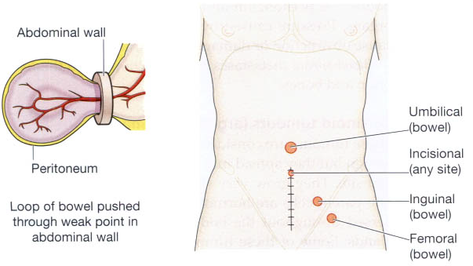

**Figure:** Hernias: **A.** Strangulated hernia formation. **B**. Common sites of herniation.

**Hernias**

* When the contents of hernia such as loop of intestine can be returned to the abdominal cavity, it is called ***reducible****.*
* When it is not possible to reduce hernia due to large contents or due to adhesions in the hernial sac, it is referred to as ***irreducible****.*
* When the blood flow in the hernial sac is obstructed, it results in ***strangulated hernia****.*
* Obstruction to the venous drainage and arterial supply may result in **infarction** or **gangrene** of the affected loop of intestine.

**Peritoneal Adhesions and Bands**

* Adhesions and bands in the peritoneum composed of **fibrous** **tissue** result following healing in peritonitis.
* It result in partial or complete intestinal obstruction by outside pressure on the bowel wall.

**Intussusception**

* It is the telescoping of a segment of intestine into the segment below due to **peristalsis**.
* The telescoped segment is called the ***intussusceptum***and lower receiving segment is called the ***intussuscipiens****.*
* The condition occurs more commonly in infants and young children.
* The main ***complications***of intussusception are **intestinal obstruction**, **infarction**, **gangrene**, **perforation** and **peritonitis**.

**Volvulus**

* Volvulus is the **twisting of loop of intestine** upon itself through 180° or more.
* This leads to obstruction of the intestine as well as **cutting off** of the **blood supply** to the affected loop and causing **gangrene**.
* The usual causes are **bands and adhesions** and **long mesenteric attachment**.
* The condition is more common in the sigmoid colon than the small bowel.

**GASTRIC CARCINOMA**

**INCIDENCE.**

* Carcinoma of the stomach comprises more than 90% of all gastric malignancies and is the leading cause of cancer-related deaths in countries where its incidence is high.
* The highest incidence is between 4th to 6th decades of life and is twice more common in men than in women.

**ETIOLOGY.**

* 1. ***H. pylori infection,*** important risk factor
  2. ***Dietary factor*** e.g. salty, nitrates, hot and spicy food, tobacco smoke, tobacco juice, alcohol
  3. ***Geographical factor*** e.g. high in Japan, Chile, Italy
  4. ***Racial factor*** e.g. high in blacks, low in UK, USA, Canada
  5. ***Genetic factor***
  6. ***Pre-malignant changes in gastric mucosa*** e.g. ulcer, neoplasia

**MORPHOLOGIC FEATURES.**

Gastric carcinoma is most commonly located in the region of **gastric canal** (prepyloric region) formed by lesser curvature, pylorus and antrum. Other less common locations are the body, cardia and fundus.

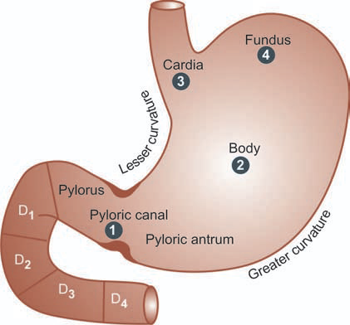

**Fig: Distribution of gastric carcinoma** in the anatomical subdivisions of the stomach. The serial numbers in the figure indicate the order of frequency of occurrence of gastric cancer.

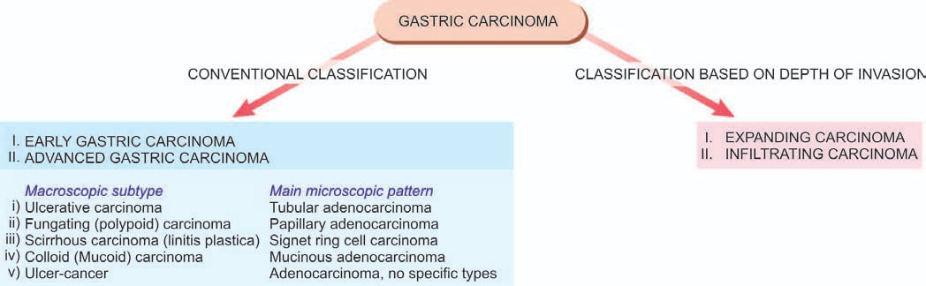

**Fig: Classifications of gastric carcinomas. A,** Conventional classification, showing correlation of the macroscopic subtypes with the main histological patterns. **B,** Classification based on the depth of invasion by the tumour.

On the basis of ***extent of invasion,*** into 2 groups:

1. ***Expanding carcinomas*** that grow **laterally** by an invasive margin. The tumour cells are in the form of **cohesive** **clusters**.
2. ***Infiltrating carcinomas*** have poorly-defined invasive border. The tumour cells are **loose** and invade **singly** or in **small group**.
3. **Early Gastric Carcinoma (EGC)**

EGC is the term used to describe cancer limited to the **mucosa** and **submucosa**. The diagnosis can be made possible by the use of fibreoptic endoscope and gastrocamera.

***Grossly,*** the lesion of EGC may have 3 patterns—**polypoid, superficial** and **ulcerated**:

Type I : Polypoid type

Type IIa : Superficial elevated

Type II b : Superficial flat

Type II c : Superficial depressed

Type III : Ulcerated type

***Histologically,*** typical glandular adenocarcinma type.

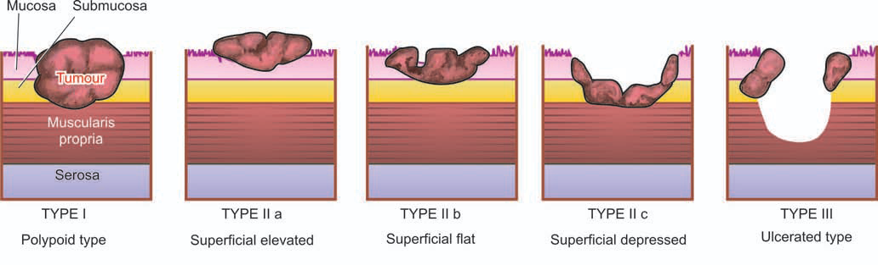

**Fig:** Diagrammatic representation of gross patterns of early gastric carcinoma.

1. **Advanced Gastric Carcinoma**

When the carcinoma **crosses** the basement membrane into the muscularis propria or beyond, it is referred to as advanced gastric carcinoma.

It has following 5 patterns:

1. **Ulcerative carcinoma**

* Most common pattern, tumour appears as a **flat**, **infiltrating** and **ulcerative** growth with irregular **necrotic** **base** and **raised margin**, seen more commonly in the region of gastric canal
* ***Histologically,*** they invade deeply into the stomach wall. Tubular and acinar patterns are seen more commonly.

1. **Fungating (polypoid) carcinoma**

* Thesecond common pattern is a **cauliflower** **growth** projecting into the lumen.
* The tumour undergoes **necrosis** and **infection** commonly.

1. **Scirrhous carcinoma (Linitis plastica)**

* The stomach wall is thickened due to extensive **desmoplasia** giving the appearance as ‘leather-bottle stomach’.
* The lumen of the stomach is reduced. There are no ulcers but rugae are prominent.

***Histologically,*** it may be an adenocarcinoma or **signet** **ring cell carcinoma**, extensively **infiltrating** the stomach wall, and **desmoplasia** cancer cells.

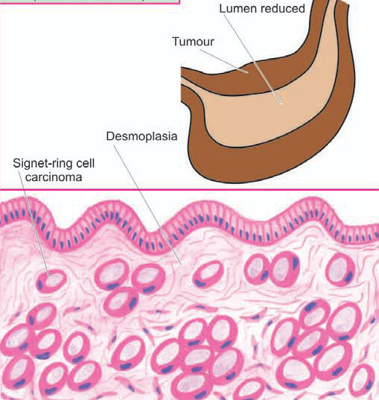

1. **Colloid (Mucoid) carcinoma**

Usually seen in the fundus. The tumour grows like masses having **gelatinous** appearance due to secretion of large quantities of **mucus**.

***Histologically,*** mucoid carcinoma contains abundant pools of **mucin** in which are seen a small number of **tumour cells**, sometimes having **signet-ring** appearance.

1. **Ulcer-cancer**

Majority of ulcer-cancers are malignant lesions from the beginning. They are adenocarcinomas.

**SPREAD**

1. **Direct spread**.

Direct spread by local extension is the most . The spread occurs mainly from the loose submucosal layer but eventually muscularis and serosa are also invaded.

**2. Lymphatic spread.**

Metastases to regional lymph nodes and others.

**3. Haematogenous spread.**

Spread to liver, lungs, brain, bones, kidney, etc.

**CLINICAL FEATURES.**

* 1. Persistent abdominal pain
  2. Gastric distension and vomiting
  3. Loss of weight
  4. Loss of appetite
  5. Anaemia, weakness, malaise.

**COMPLICATION**

* 1. Haemorrhage
  2. Obstruction
  3. Perforation
  4. Jaundice.

**COLORECTAL CARCINOMA**

* Comprises about **98%** of all malignant tumours of the large intestine.
* **Commonest form** of visceral cancer accounting for deaths from cancer in the United States, **next only to lung cancer**.
* Incidence of carcinoma of the large intestine rises with age; average age of patients is about **60 years**.
* Cancer in the rectum is more common in males than females in the ratio of 2:1.

**ETIOLOGY.**

Not clear but a few etiological factors have been implicated:

1. **Geographic variations.** E.g. Socioeconomic status of country, more common in North America, Northern Europe than in South America, Africa and Asia.
2. **Dietary factors.** E.g. Low intake of vegetable fibre diet, high intake of fatty foods and refined carbohydrates
3. **Adenoma-carcinoma sequence.** E.g. pre-existing adenomas, its number, size and type
4. **Hereditary.** E.g. mutation in hMLH2 (human mutL homolog) gene located on chromosome 2 and 3.
5. **Other factors.** E.g. inflammatory bowel disease, diverticular diseases, tobacco smoking, etc.

**MORPHOLOGIC FEATURES.**

About **60%** of the cases occur in the **rectum**, followed in descending order, by sigmoid and descending colon (25%), caecum and ileocaecal valve (10%); ascending colon, hepatic and splenic flexures (5%); and quite uncommonly in the transverse colon.

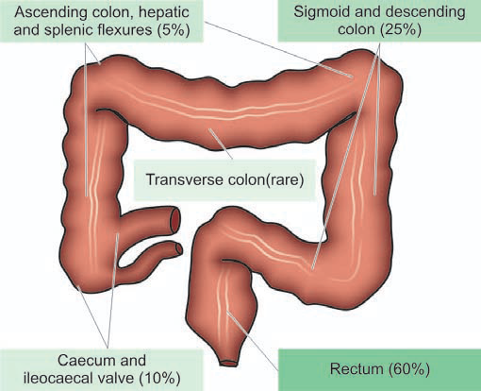

**Fig: Distribution of the primary colorectal cancer.**

***Grossly,*** there are distinct differences between the growth on the right and left half of the colon.

* **Right-sided colonic growths** tend to be large, **cauliflower-like**, soft and friable masses projecting into the lumen *(fungating polypoid carcinoma).*
* **Left-sided colonic growths,** have **napkin-ring** configuration i.e. they encircle the bowel wall circumferentially with **increased fibrous tissue** with **central ulceration** on the surface with slightly elevated margins *(carcinomatous ulcers).*

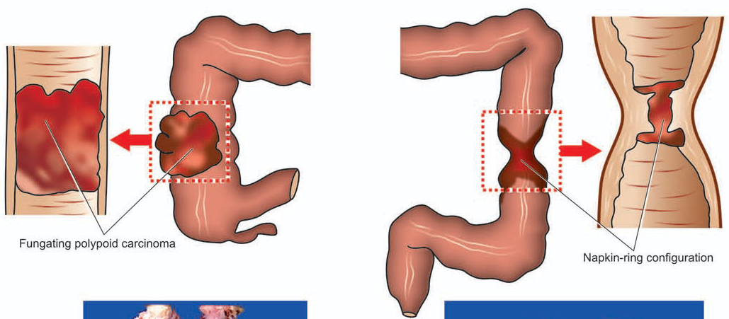

* These differences in right and left colonic growths are probably due to the **liquid** **nature** of the contents in the **ascending colon** leaving space for luminal growth on right side, while the contents in **left colon** are more **solid** permitting the spread of growth into the bowel wall.

***Microscopically,***

* About **95%** of colorectal carcinomas are **adenocarcinomas** with **mucin-secreting** colloid carcinomas.
* The remaining **5%** tumours include **uncommon** microscopic patterns like undifferentiated carcinoma, signet-ring cell carcinoma, and adeno-squamous carcinomas.

**SPREAD**

1. **Direct spread**.

Spread by direct extension

**2. Lymphatic spread.**

Metastases to regional lymph nodes and others.

**3. Haematogenous spread.**

Spread to liver, lungs, brain, bones, ovary, etc.

**CLINICAL FEATURES.**

* 1. Occult bleeding (melaena)
  2. Change in bowel habits, more often in left-sided growth
  3. Loss of weight (cachexia)
  4. Loss of appetite (anorexia)
  5. Anaemia, weakness, malaise.

**COMPLICATIONS**

* 1. Obstruction
  2. Haemorrhage
  3. Perforation
  4. Secondary infection

**DIAGNOSIS**

* + Stool test for occult blood,
  + Proctoscopy,
  + Radiographic contrast studies and CT scan,
  + Tumour markers i.e. estimation of carcinoembryonic antigen (CEA) level.

**THE END**

**BEST OF LUCK…….!!!**